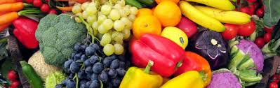

Join us via phone, tablet, or computer!
The Expanded Food and Nutrition Education Program (EFNEP) can show you how to eat healthier and be more active.
Limited-income parents/caregivers who participate learn how to make food choices to improve the quality of the meals they serve their family. EFNEP offers a FREE & FUN series of nine, 45-minute workshops via live interactive online Zoom meetings. After completing the series, you will receive a certificate from OSU and a couple small gifts.

Open Series start dates:
Monday, October 5th 6-7 p.m.
Thursday, October 15th 6-7 p.m.
To receive program access, advance registration is required a week before the series starts.
To register, email your name, phone & zip code to:
Tanya North at North.117@osu.edu

